Annex B
SAJC H2 Maths Prelim :

Qn/No | Topic Set | Paper Number | Answers | Marks
1 | Binomial Expansion | 9740/01 | a = 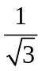, b = 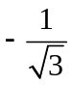, c = 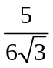 | 4
2 | Mathematical Induction | 9740/01 |  | 6
3 | Inequalities + Integration | 9740/01 | (i) 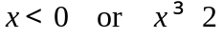  (ii) a = 4 | 6
4 | Complex Numbers (Loci) | 9740/01 | (ii)(a) 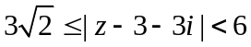  (ii)(b) 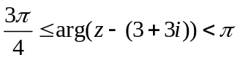 | 6
5 | Maclaurin's Series | 9740/01 | (ii) 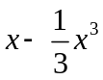  (iii) 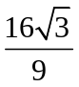  (iv) 0 | 7
6 | Tangent and Normal | 9740/01 | (i) 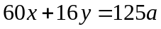  (ii) 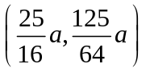  (iii) 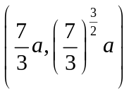 and 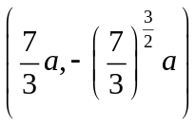 | 8
7 | Functions | 9740/01 | (i) 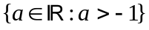  (ii) 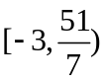  (iii) 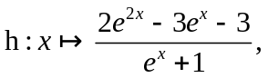  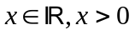 | 8
8 | Maxima-Minima + Rate of Change | 9740/01 | (a) 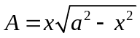  (b) 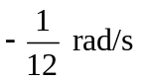 | 10
9 | Vectors (lines) | 9740/01 | (ii) 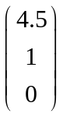  (iii) 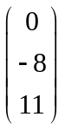  (iv) 14.9; 53.6;  Perpendicular/shortest distance from point X to line AB. | 11
10 | Vectors (planes) | 9740/01 | - 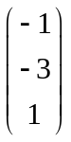; 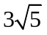  - 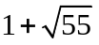  (iii) 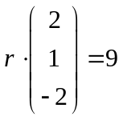 | 11
11 | Area & Volume | 9740/01 | (a)(i) 2.76 units²  (a)(ii) 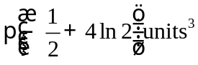  (b)(ii) 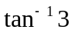 | 11
12 | Integration | 9740/01 | (a) 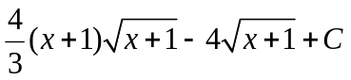  (b) 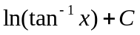  (c)(i) 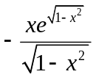  (c)(ii) 1 | 12
 | Pure Maths
1 | Summation/Method of Difference | 9740/02 | (ii)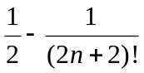 | 6
2 | AP & GP | 9740/02 | (ii) 5  (iii)56 | 7
3 | Transformations | 9740/02 | (b) 1. Translate the graph of 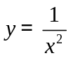 by 2 units in the positive x direction  2. Stretch the resulting graph parallel to the y-axis with a scale factor of -4.  3. Translate the resulting graph by 1 unit in the positive y direction. | 6
4 | Differential Equations | 9740/02 | (ii)k < 0  A vaccination had been found to eliminate the virus OR  The people infected by the virus had passed away | 8
5 | Complex Numbers | 9740/02 | (a) k = 2  (b) 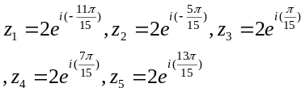 | 13
 | Statistics
6 | P & C | 9740/02 | 31 | 3
7 | Sampling | 9740/02 | (ii) Quota Sampling | 6
8 | Normal Distribution | 9740/02 | (i) 275  (ii) 344 | 5
9 | Probability | 9740/02 | (i)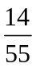  (ii)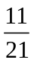 | 7
10 | Poisson Distribution | 9740/02 | 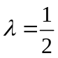; 0.392; 0.714 | 7
11 | Hypothesis Testing | 9740/02 | (i)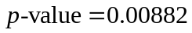; reject H₀  (ii) conclusion in (i) does not change  (ii) 60 | 10
12 | Linear Regression and Correlation | 9740/02 | (ii) From the scatter diagram, the regression line of y on x should have negative gradient. Therefore 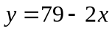 is the correct regression line of y on x.  (iii) (35, 18)  (iv) -0.933  (v) 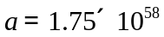; b = − 33.6 | 10
13 | Binomial Distribution | 9740/02 | (ii) 0.923  (iii) 0.299  (iv) 11  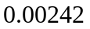 | 12

